St Mary’s C.E. Primary and Nursery School



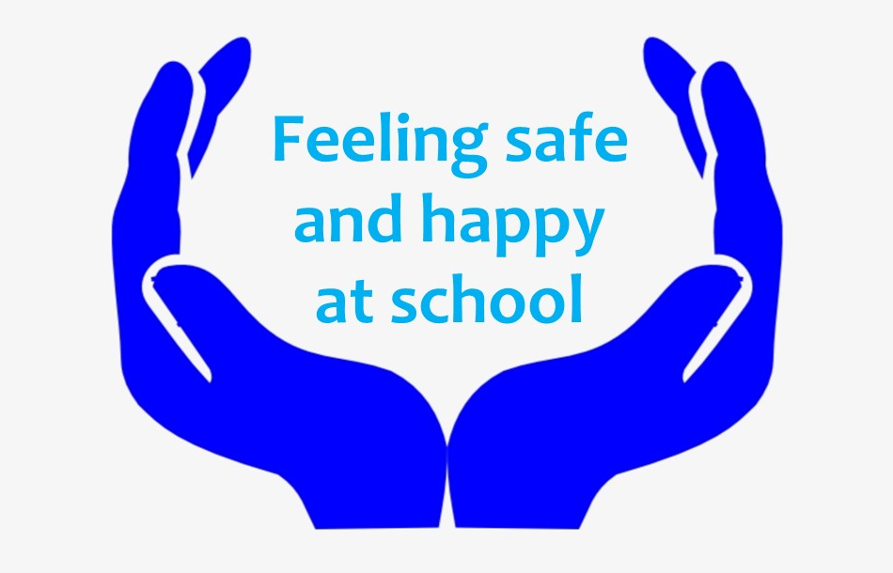


Child-Friendly Anti-Bullying Policy

Feeling safe and happy at school
At St Mary’s School, we want to make sure that you feel looked after, safe and happy when you are in and out of school.

Sometimes we don’t know if something bad is happening, so you need to tell us.

This policy looks at bullying, and what you can do when you feel you are being bullied, or when you notice someone else being bullied.

We can help you by:

- Helping you to know what bullying is.
- Teaching you what to do if you feel like you are being bullied, or if someone else is being bullied.
- Helping you know which grown-ups you can speak to.




What is bullying?

A bully is someone who hurts another person more than once, by using behaviour which is meant to scare, harm or upset that person.

At our school, we use the word ‘STOP’ to identify bullying:

S | everal
T | imes
O | n
P | urpose

It is important to remember that single problems and falling out with friends are not bullying.

Bullying is behaviour which is repeated on purpose and is meant to upset someone.


Types of bullying
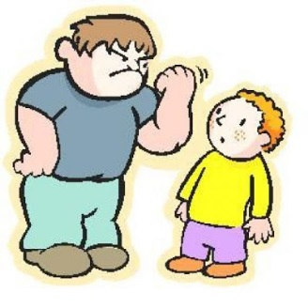
Bullying can be different things, and isn’t just hitting or kicking another person.

Emotional bullying is hurting someone’s feelings, leaving them out or bossing them about.

Physical bullying is punching, kicking, spitting, hitting or pushing someone.

Verbal bullying is teasing someone, calling them names or using hand signs. People can also use verbal bullying to be racist or sexist.

Racist means bullying someone because of their skin colour, race or what they believe in.

Homophobic means bullying someone because of their gender or sexuality; calling someone gay or lesbian would be homophobic.

Sexist means bullying someone because of their sex (whether they are a boy or a girl).

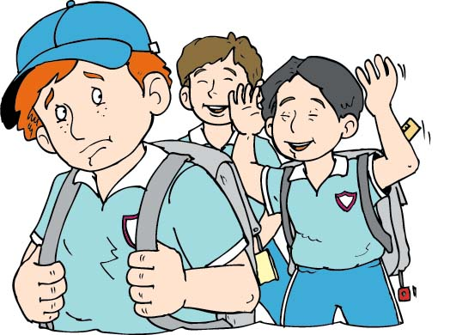
Cyber bullying involves sending horrid messages over the internet through social media or by a message such as texts, Snapchat and Whatsapp.

Bullying can be done through another person, by one person sending another person to say nasty things.


What should I do if I am being bullied?

If you are being bullied, the first thing you should do is tell the bully to stop.

You can also:

- Make eye contact and tell the bully to leave you alone.
- Ignore the bully and walk away.
- Tell a grown-up, such as your parent, carer or teacher.
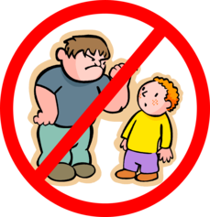
You should try not to:

- Do what the bully says.
- Let what the bully says or does upset you.
- Get angry or physically hurt them.

Always remember that if you are being bullied, it is not your fault and you are never alone.

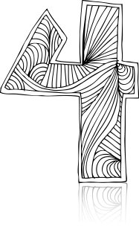
You shouldn’t be scared to talk to someone if you are being bullied. If you talk to a grown-up, we can make the bullying stop.

What should I do if I see someone else being bullied?

If you see someone else being bullied, it is important that you help that person.

You should never walk away and ignore the bullying if you see someone else being bullied, because the bully will keep on upsetting that person.
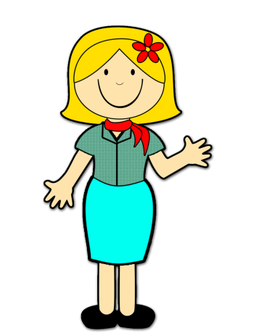
If you can, and it is safe, tell the bully to stop, but never get angry or physically hurt them.

Tell a grown-up, such as a teacher, as soon as you’ve seen someone being bullied.

Grown-ups can stop the bullying and make that person feel happy again.

You should never feel scared to tell someone about bullying.

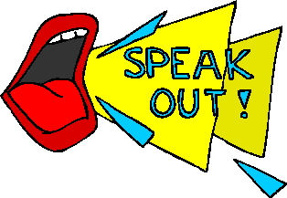
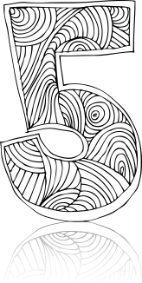
Who can I talk to?

It is important that you tell someone as soon as you are being bullied, or you notice someone else being bullied.

Speaking to someone like your mum, dad, carer or teacher will mean that we can make sure the bullying stops and doesn’t happen again.


How can I help stop bullying from happening?

We can all help stop bullying at our school by:
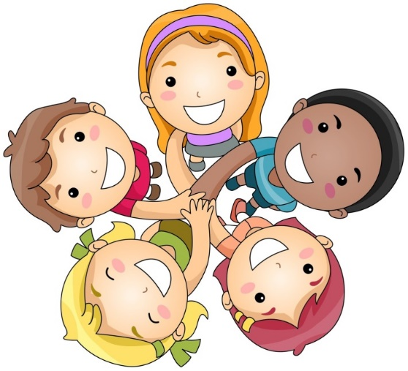
- Making sure we keep to the rules in this guide.
- Helping others when they are in need.
- Being kind, friendly and respectful to others.
- Thinking about people’s feelings before we say or do something.
- Taking part in PSHE, assemblies and anti-bullying week.

